
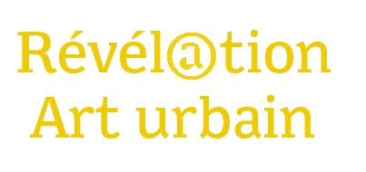

2020 APPLICATION FORM

Applications to be sent to revelationarturbain@adagp.fr
Until August 28, 2019 at 2 p.m. included.
(date and time of the e-mail authentic)

Candidate
Mr. or Mrs:
Name:
First Name:
Pseudo:
Address:
Postal code: City:
Cellphone:
Mail:
Site Internet:
☐ I declare that I have read the rules of Revelation Art Urbain and accept it in its entirety.
Made in:
Date :

Signature preceded by "Read and approved"

